**Question 1:** Use the NULL keyword to display the cust_number, cust_name and cust_city for records that have no value for the field cust_street in the table MSC_CUSTOMER.

* To find records with NULL values for their cust_street has no value, SELECT cust_number, cust_name, cust_street, cust_city FROM the MSC_CUSTOMER table, isolating rows where cust_street is NULL.
* *SELECT cust_number, cust_name, cust_street, cust_city FROM MSC_CUSTOMER WHERE cust_street IS NULL*

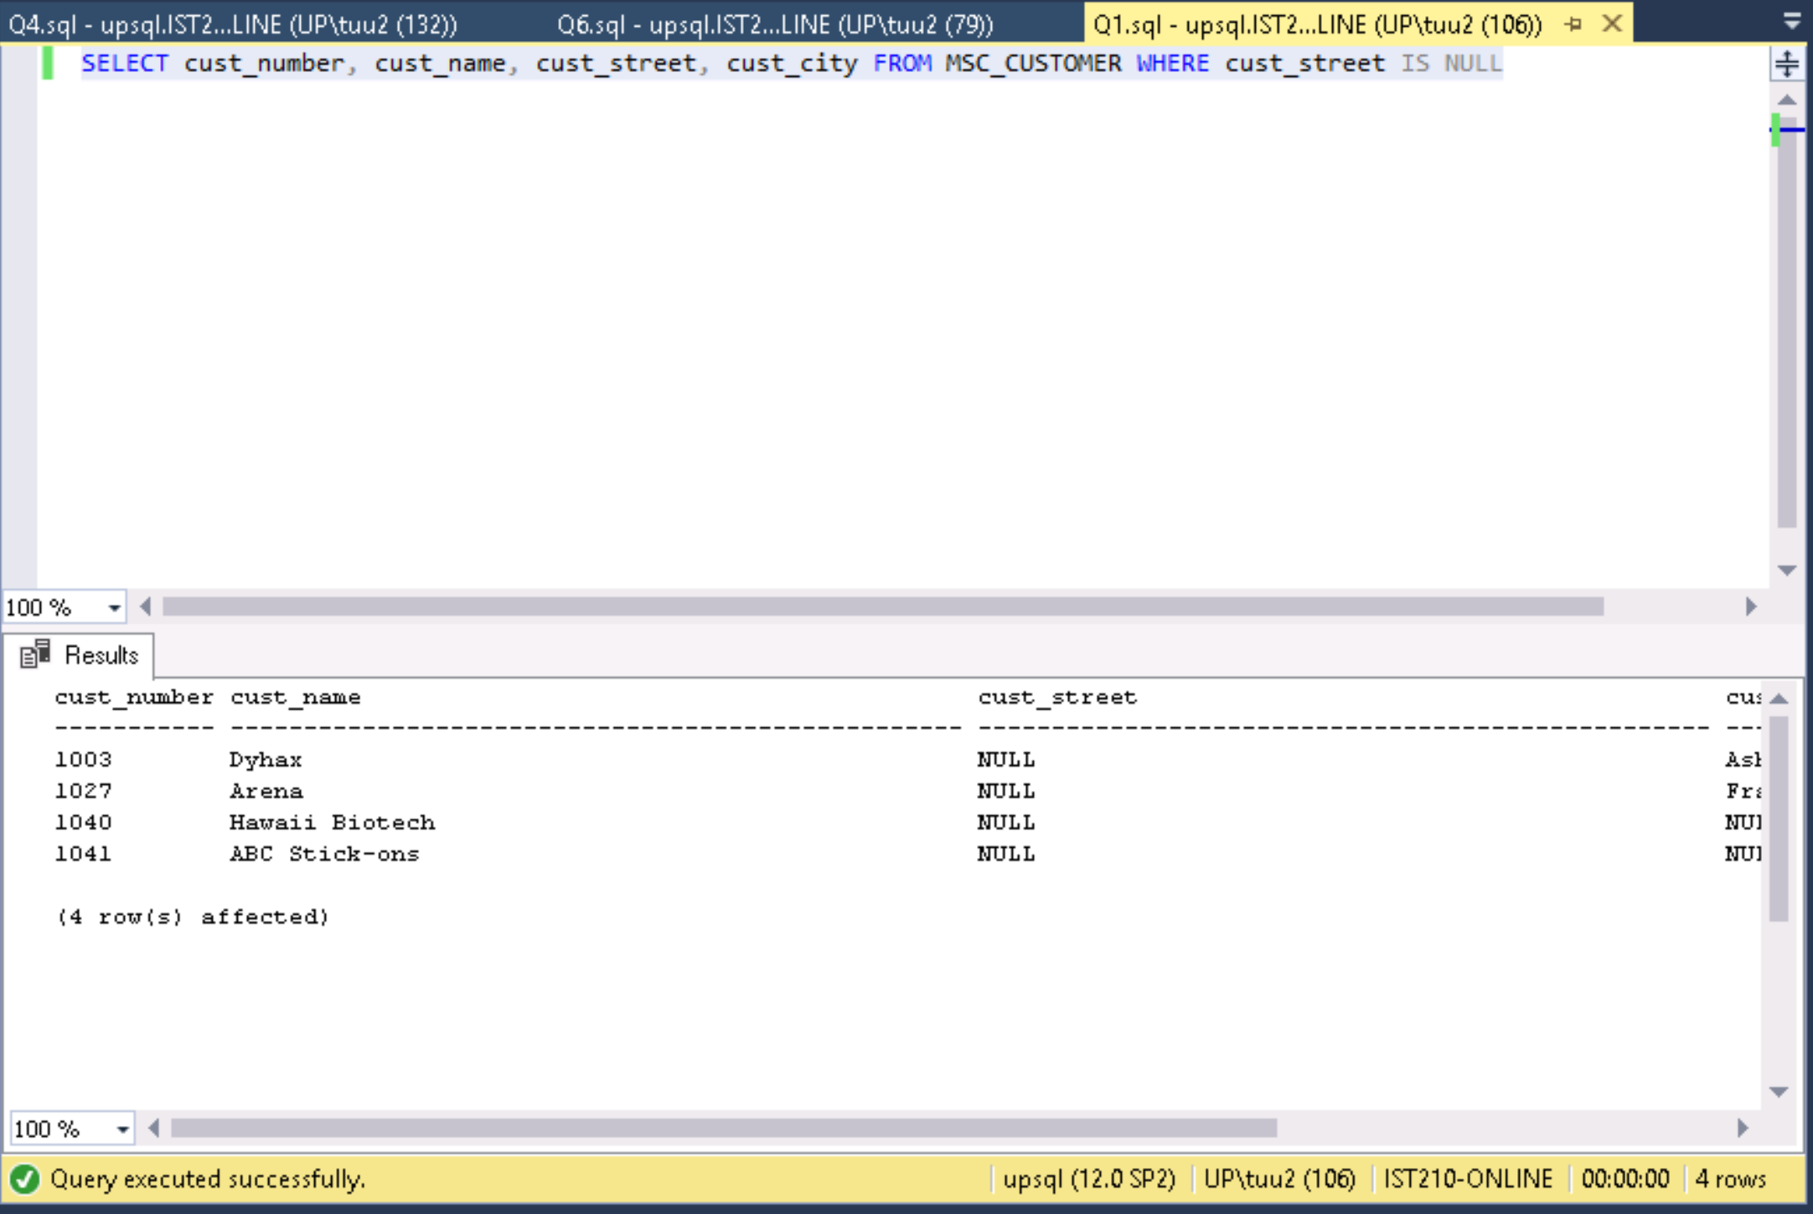

cust_number cust_name cust_street cust_city

------------------------------------------------------------------------------------------------------------------

1003 Dyhax NULL Ashland City

1027 Arena NULL Franklin

1040 Hawaii Biotech NULL NULL

1041 ABC Stick-ons NULL NULL

(4 row(s) affected)**Question 2:** Display empl_first_name, empl_last_name and job_code for employee number 228.

* To display empl_first_name, empl_last_name and job_code, use a SELECT statement for those values FROM the MSC_Employee table, choosing WHERE the empl_number matches empl_number=228.
* *SELECT empl_first_name, empl_last_name, job_code FROM MSC_Employee WHERE empl_number=228*

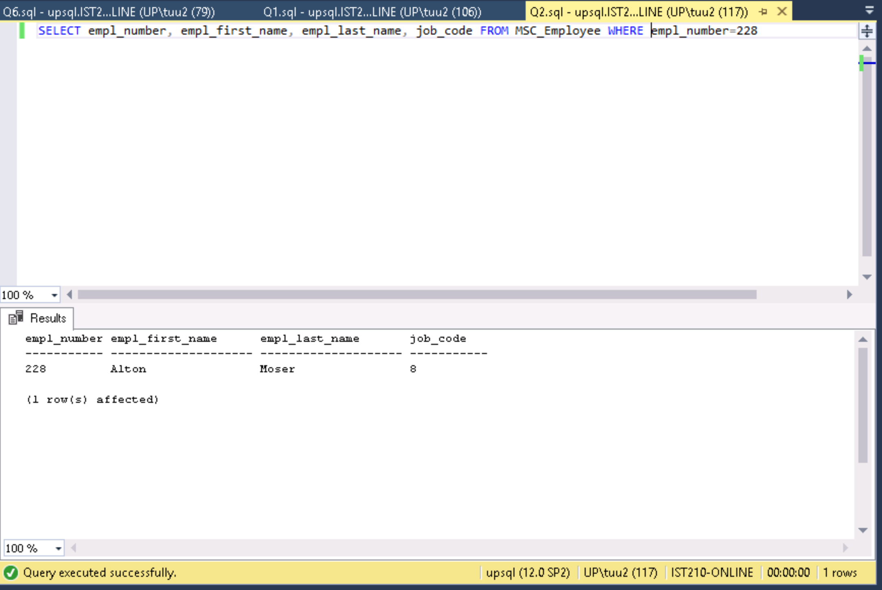

**empl_number empl_first_name empl_last_name job_codeas**

**----------- -------------------- -------------------- -----------**

**228 Alton Moser 8**

**(1 row(s) affected)**

**Question 3:** Display the product number, vendor number and quantity in stock value for product detail where the quantity in stock is in the 400 to 500 range from the MSC_product_detail table sorted in descending order by quantity in stock value.

* To display ‘prod_number’, ‘vend_number’ and ‘qty_in_stock’, SELECT those values from ‘MSC_product_detail’ table, isolating only rows WHERE ‘qty_in_stock’ is BETWEEN 400 AND 500, choosing to order the rows by using ORDERBY qty_in_stock in DESC order.
* *SELECT prod_number, vend_number, qty_in_stock FROM MSC_Product_detail WHERE qty_in_stock BETWEEN 400 AND 500 ORDER BY qty_in_stock DESC*

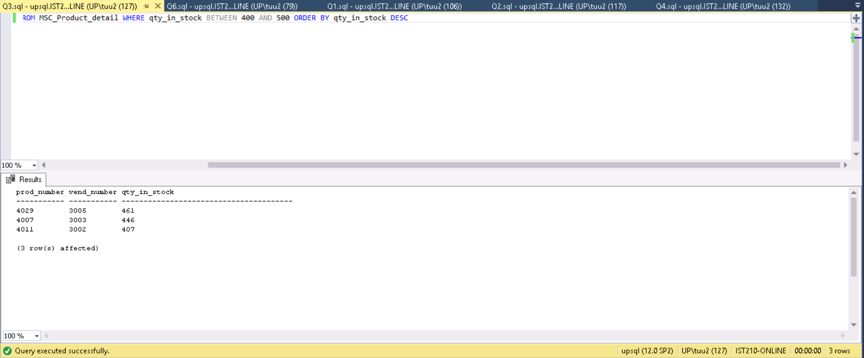

prod_number vend_number qty_in_stock

----------- ----------- ---------------------------------------

4029 3005 461

4007 3003 446

4011 3002 407

(3 row(s) affected)

**Question 4:** Display the number (tally) of customers who are located in the state of North Carolina.

* To find customers in state of North Carolina, SELECT cust_num (PK) from the MSC_Customer table, identifying customers WHERE their ‘cust_state’ is in NC (North Carolina state code).
* *SELECT cust_number, cust_name, cust_state FROM MSC_Customer WHERE cust_state ='NC'*

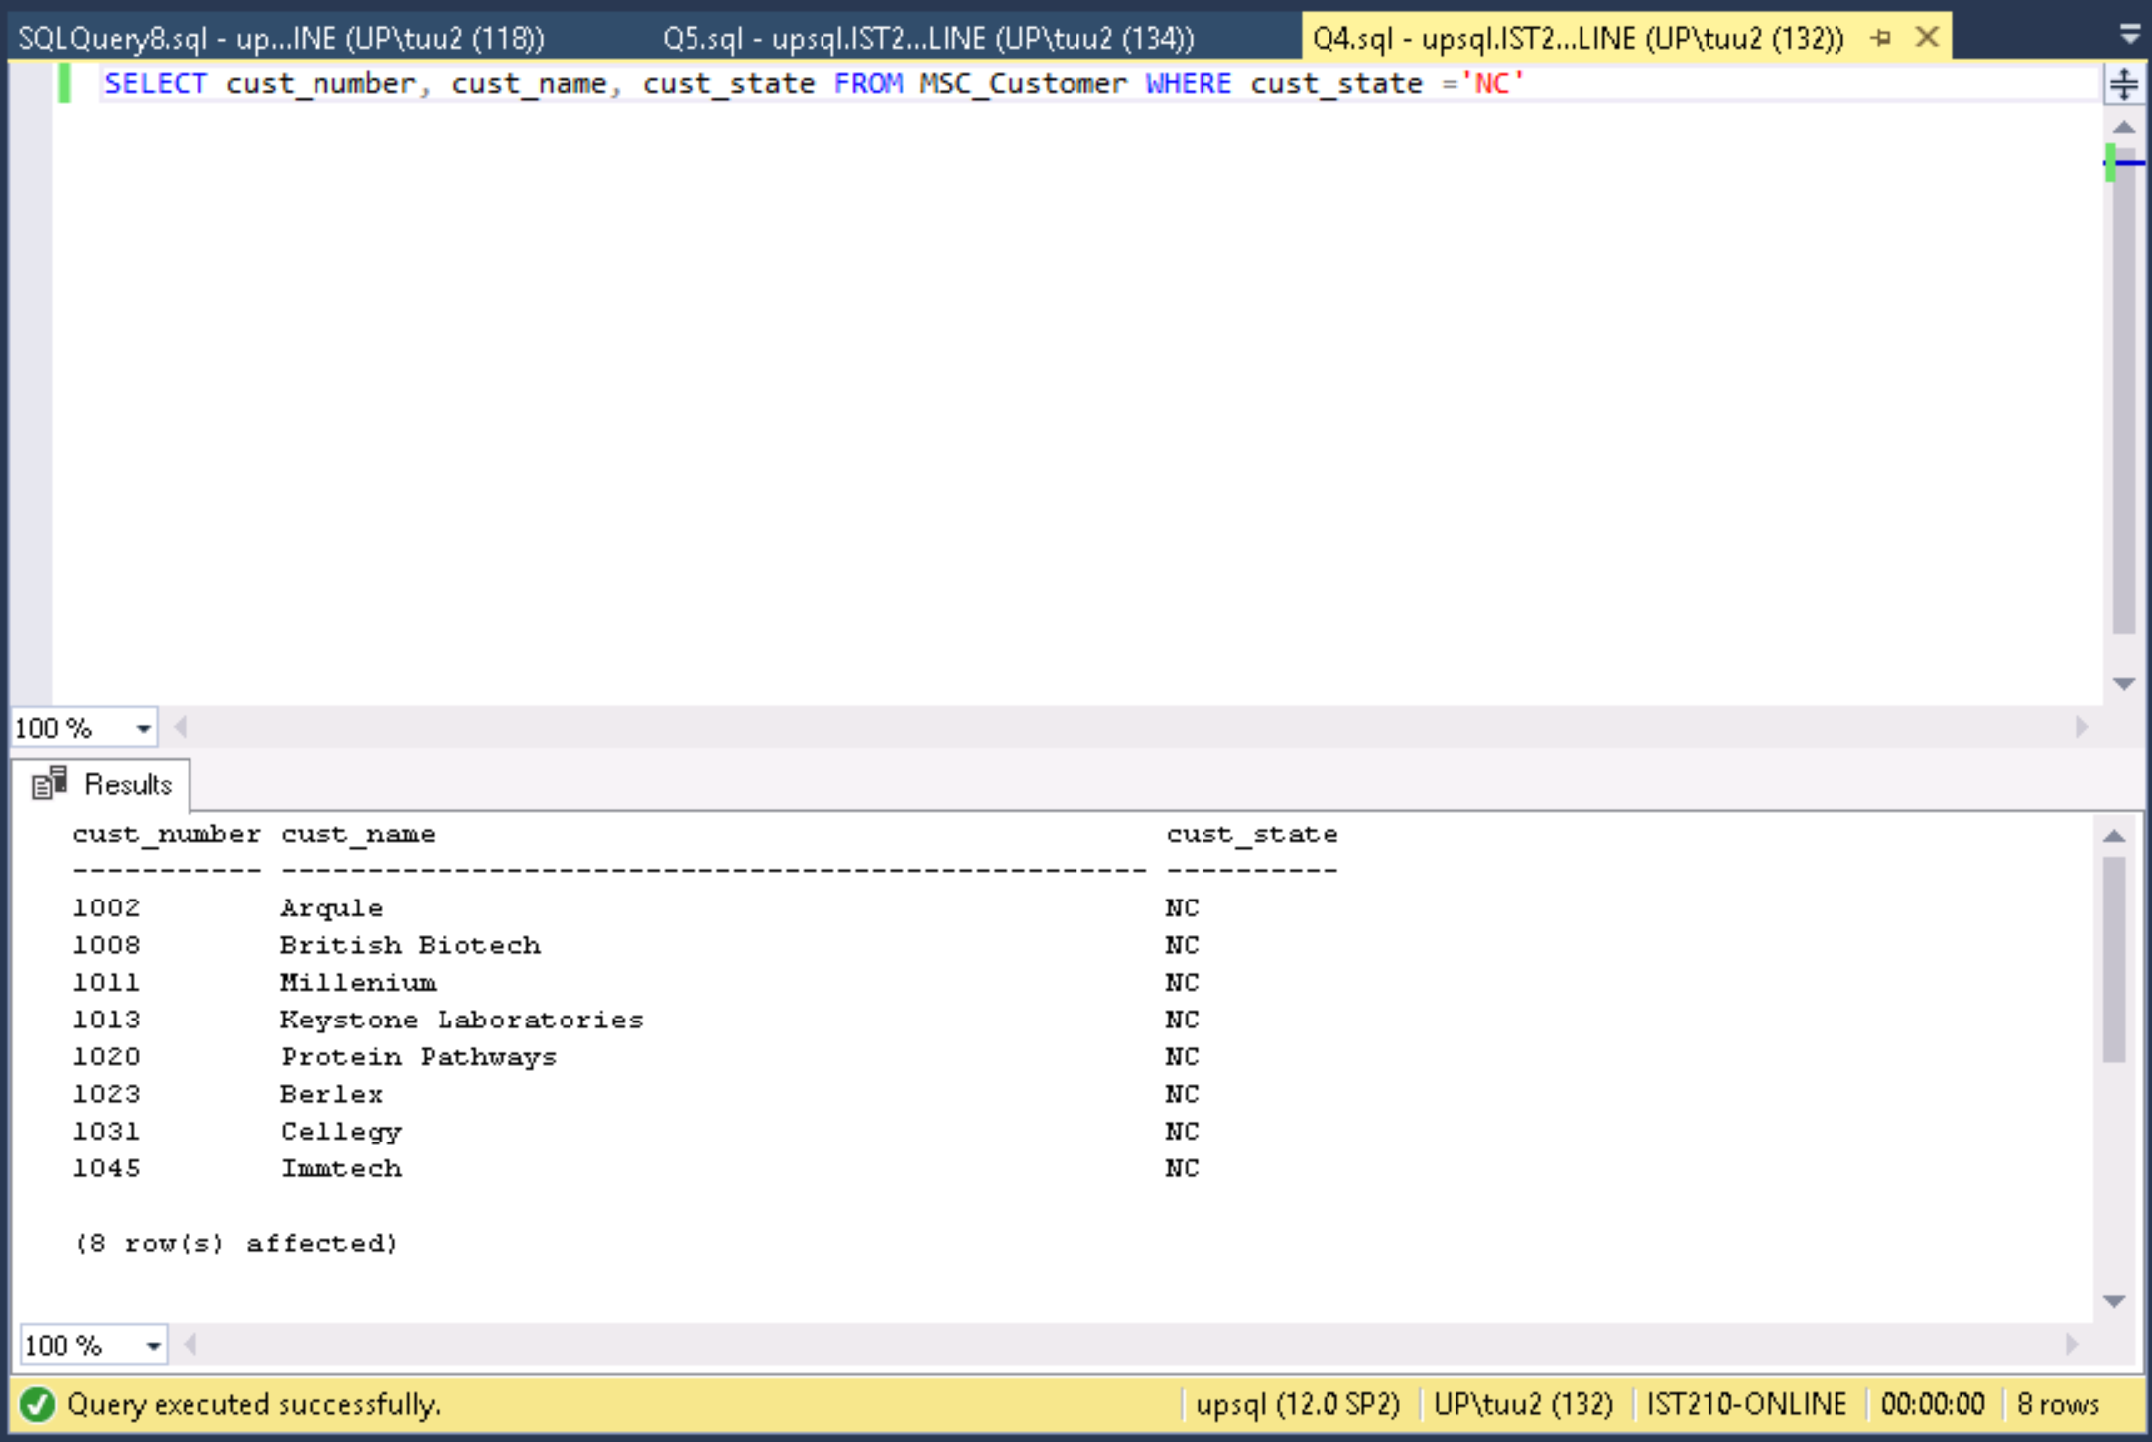

cust_number cust_name cust_state

----------- -------------------------------------------------- ----------

1002 Arqule NC

1008 British Biotech NC

1011 Millenium NC

1013 Keystone Laboratories NC

1020 Protein Pathways NC

1023 Berlex NC

1031 Cellegy NC

1045 Immtech NC

(8 row(s) affected)

**Question 5:** Display the minimum, maximum and average ship quantities for all order details. Note: only include entries if the order has been shipped.

* To display min, max, and avg ship quantities for all orders, select MIN, MAX, and AVG order quantities (ord_quantity) FROM MSC_Order_detail table, making sure that the ones selected to be min/max/avg are shipped (aka not null for ship date.
* *SELECT MIN(ord_quantity), MAX(ord_quantity), AVG(ord_quantity) FROM MSC_Order_detail WHERE ship_date is not NULL*

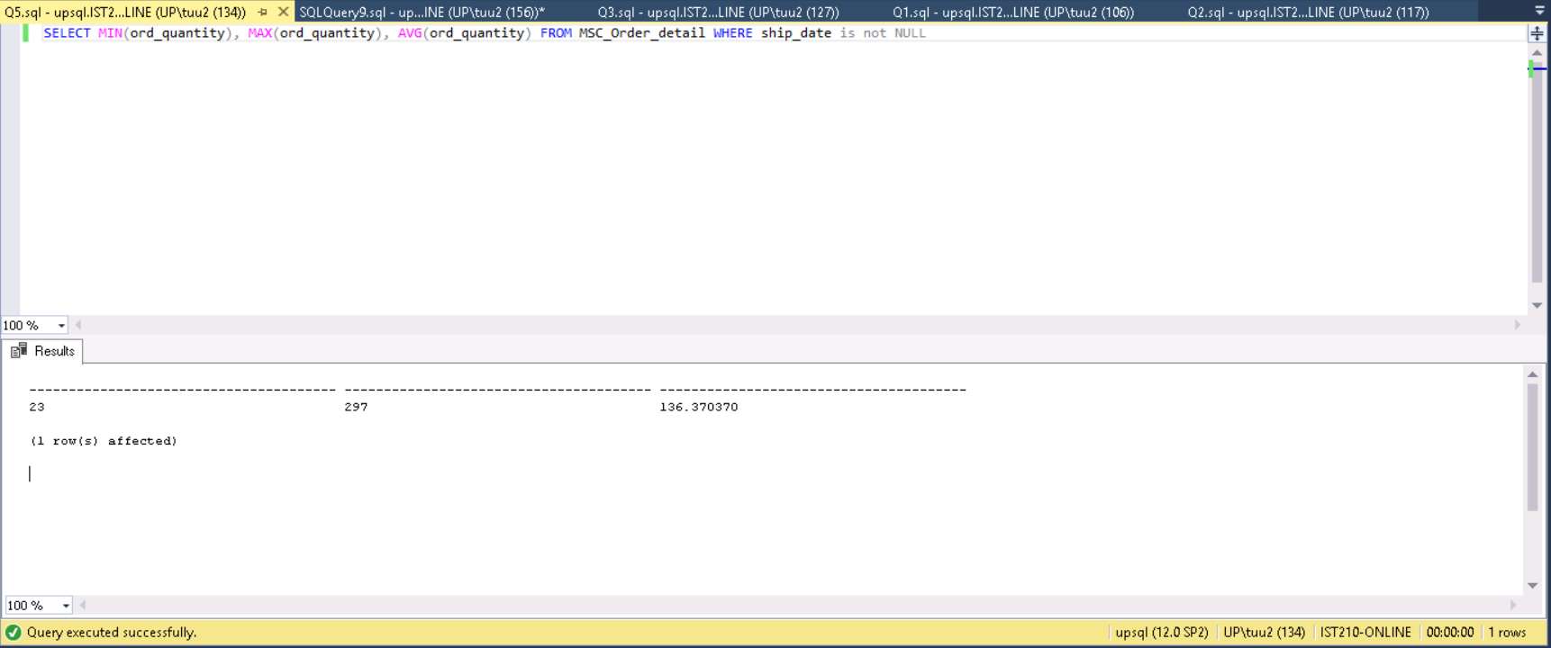

**(Min) (Max Avg**

**------------------------------------------------------------------------------------------------------------------**

**23 297 136.370370**

**(1 row(s) affected)**

**Question 6:** Display employee number, first name and last name when the employee’s last name contains a letter ‘S’ (upper or lower case) anywhere in the last name.

* To show employees with last name containing the letter ‘s’, select from Employees table columns “empl_number,empl_first_name, and empl_last_name”, then put search using LIKE for regex ‘%s%’ to find last names with character ‘s’ in them.
* *SELECT empl_number,empl_first_name, empl_last_name FROM MSC_Employee WHERE empl_last_name LIKE '%s%'*

empl_number empl_first_name empl_last_name

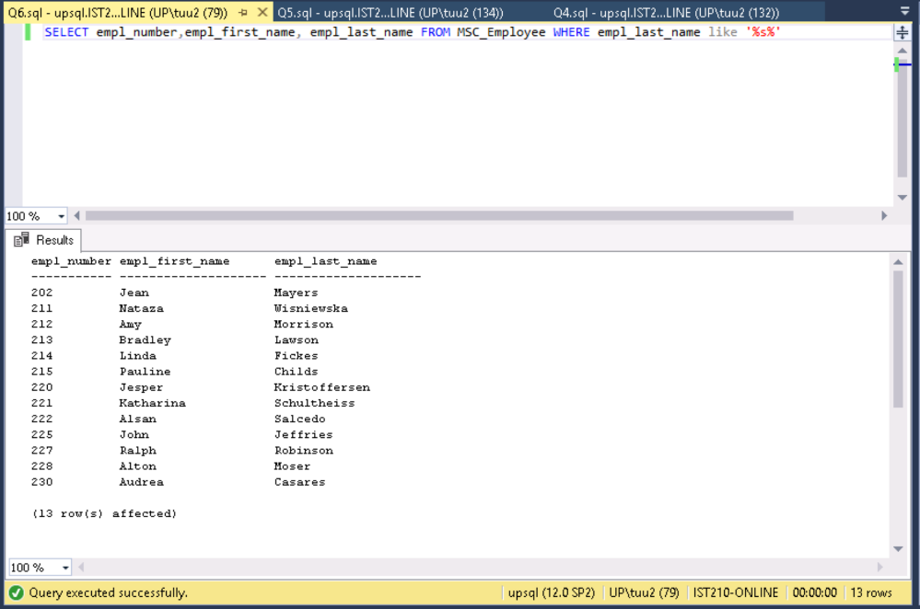----------- -------------------- --------------------

202 Jean Mayers

211 Nataza Wisniewska

212 Amy Morrison

213 Bradley Lawson

214 Linda Fickes

215 Pauline Childs

220 Jesper Kristoffersen

221 Katharina Schultheiss

222 Alsan Salcedo

225 John Jeffries

227 Ralph Robinson

228 Alton Moser

230 Audrea Casares

(13 row(s) affected)